

Vocabulary

Complete the sentences with these words.
actor athlete lawyer librarian politician soldier
  - After the car accident, the police officers told my father to speak to a .
  - The who won the gold in the 100 metres is from my hometown.
  - My best friend is an . She was in three plays and now she’s in a Hollywood film!
  - My grandfather wanted to fight in the war for his country, so he became a .
  - The said that the government will help young people get jobs.
  - That is very kind. When I took my books back late, he didn’t make me pay anything.

Choose the correct options to complete the text.
At school today, we had to do a personality test on an app on the computer. Then the app suggested careers for us. My problem is that I’m very ¹ sociable / shy. It’s difficult for me to talk to other people, especially in big groups. I get
² nervous / serious in situations like that. My heart starts going really fast and I get very hot. I would like to be more
³ generous / confident, but I’m not.
I have some good qualities, though. I’m ⁴ honest / reliable. I’m never late and I always do my work on time. In fact, I’m very ⁵ hard-working / relaxed. In my part-time job as a shop assistant, I often stay late and help. I’m also good with children because I’m ⁶ dangerous / patient with them when they can’t do something. And when they’re bad or noisy, I stay ⁷calm / unkind. I don’t get angry.
The computer’s first job for me was a children’s librarian. I love books, so that idea made me feel very ⁸ cheerful / miserable. The other jobs it suggested were great too. Not bad for an app!

The words in bold are incorrect. Write the correct word.
- I’m applying about a job in a restaurant. It’s only part-time because I’m still at school.
- Some people do married after high school, but I want to wait until I’m 25 or older.
- My best friend started seeing out with someone. She thinks she’s in love!
- When my sister goes in college, I’ll get her bedroom. It’s much bigger than mine!
- When I grow out, I’m going to move to a city like London or New York.
- My brother split off with his girlfriend, but I’m going to stay friends with her. She’s cool.

4 Read the clues and complete the puzzle. Find the hidden word.
- A saves people from burning buildings.
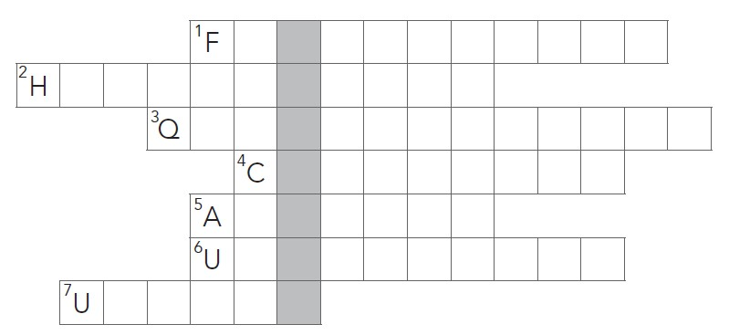
- A cuts and colours people’s hair.
- Students go to university to get a .
- Someone who applies for a job is a
.
- When you feel very worried and nervous, you are
.
- Adults who want a job but don’t have one are
.
- An person makes other people feel bad.
The hidden word is .

Grammar

Complete the sentences with the present simple or present continuous form of the verbs.
  - The farmer (keep) his animals inside in winter.
  - My boss (always / shout) at our customers. I hate it!
  - Please be quiet! The pilot (speak). I want to hear her.
  - I (always / take) my lunch to work because the food there is not good.
  - She’s the best person for the job because she (speak) five languages.
  - I’m a part-time shop assistant. I (help) at the department store on Saturdays.
  - I (work) in a fast-food restaurant at the moment, but I want to be an actor!
  - Next week, two journalists (come) to our school to talk to the students.

Choose the correct option to complete the questions.
- ‘How do you know / are you knowing Maria?’ ‘She’s in my class at school.’
- ‘Why is Paul / is Paul being so unkind to Sam today?’ ‘Paul’s jealous because Sam is going out with the girl he likes.’
- ‘Does the cake taste / Is the cake tasting good?’ ‘Yes. It’s delicious. You should have some.’
- ‘You told Lisa that I’m not pulling my weight. What do you mean / are you meaning?’
- ‘Do you think / Are you thinking that you will get the job?’ ‘I’m not sure. There were a lot of candidates.’
- ‘What do you think / are you thinking about right now?’ ‘Just the football match tomorrow.’
- ‘How much does an iPhone cost / is an iPhone costing these days?’ ‘They’re all different prices.’
- ‘When do you see / are you seeing Beatriz?’ ‘This evening. We’re going to the gym.’

Choose the correct option (a–b) to complete the sentences.
  - There was a bowl of on the table.
a fruit b fruits
  - How many are coming to the party?
a child b children
  - My isn’t coming to the wedding.
a family b families
  - Do you know thev of this school?
a history b histories
  - We left all of our at the station.
a luggage b luggages
  - There are four on each team.
a woman b women
  - You are putting a lot of on that steak!
a salt b salts
  - Could you get me two cans of in the shopping?
a tomato b tomatoes

Tick ✔ the correct sentences. Correct the mistakes in the other sentences.
- Are you listening to some new music at the moment?
- We got some good news yesterday.
- How much money do you need for your lunch?
- There aren’t many homeworks today.
- I’m sorry, but I haven’t got an advice for you.
- The school needs many new equipments.
- There are a few good candidates for the job.
- Are there much traffic on the road today?

